Contents

Setting Boiler Plate for Redux 2

[Step 1 Install dependencies: 2

Step 2: [Create Store {createStore, initializeState, compose, applyMiddleWare}] 2

Step 3: [Import Provider (from ‘react-redux’) and Store in App.js] 3

[Step 4: [Wrap Everything in App.js in Provider and Pass Store [<Provider store={store}>]] 3](#_Toc17224142)

Step 5: [Create Reducers Folder and the Corresponding index.js file for ‘combineReducers’ (from redux)and add user Defined Reducer as well {contactReducer}] 4

Step 6: [Create contactReducer (Custom Reducer)] 4

Connecting Data to Components and Dispatching Actions: 5

Step 1: [Define Types in Action Folder] 5

Step 2: [Copy State in contactReducer, import action from Types.js and use it] 6

Step 3: [Calling the GET_CONTACTS action from Contacts.js Component] [This is the Component that is supposed to display ‘Contacts’] 7

Sub step 1 [Import {Connect} from ‘react-redux’] 7

Sub Step 2: [Import GET_CONTACTS (Action Type) from types] 8

Sub Step 3: [Create mapStateToProps function, This will Get State from contactReducer (Appropriate Reducer) to the Component] 9

Sub Step 4: [Create mapDispatchToProps function, This will be calling the appropriate action type {GET_CONTACTS}, this action type, will return updated contents of state related to appropriate reducer { contactReducer}, this update state, will be equivalent to “state”, which we have parameterized to “mapStateToProps” function ] 10

Sub Step 5 : [Export “mapStateToProps” & “mapDispatchToProps” using Connect in the following format] 10

Sub Step 6: [Finally, we have to call getContactsForCurrentComponent in the “componentDidMount” to ensure for data to be available as the component loads] 11

Sub Step 7: Finally the data would be available in **variable** highlighted below, data will be available only after calling “getContactsForCurrentComponent()” function in “ComponentDidMount()” 12

Sub Step 8: Moving the Function which calls the Actions to a Separate File 12

Express Way for Learning of Actions: 14

Step 1: [Add Required Action Labels to types.js] 14

[Step 2: [Create Functions in the required “<contact>Actions” file which manipulates Global State [Data]] 15](#_Toc17224159)

Step 3: [Call these Functions in the which calls Actions ] 15

Step 4: [From Here As usual, Import Connect and Call the Functions which inturn call the actions] [DELETE CONTACT] 16

Step 5: [From Here As usual, Import Connect and Call the Functions which inturn call the actions] [ADD CONTACT] 17

Calling APIS 18

Get API [All the API needs to be called in customAction.js file {contactActions.js}] 18

Post: 19

The Sequence: 20

One 20

Two: 21

Three: 22

Four: 23

Five 24

Final 25

Redux Tutorial:

# Setting Boiler Plate for Redux

## Step 1 [Install dependencies:

npm i redux react-redux redux-thunk

## Step 2: [Create Store {createStore, initializeState, compose, applyMiddleWare}]

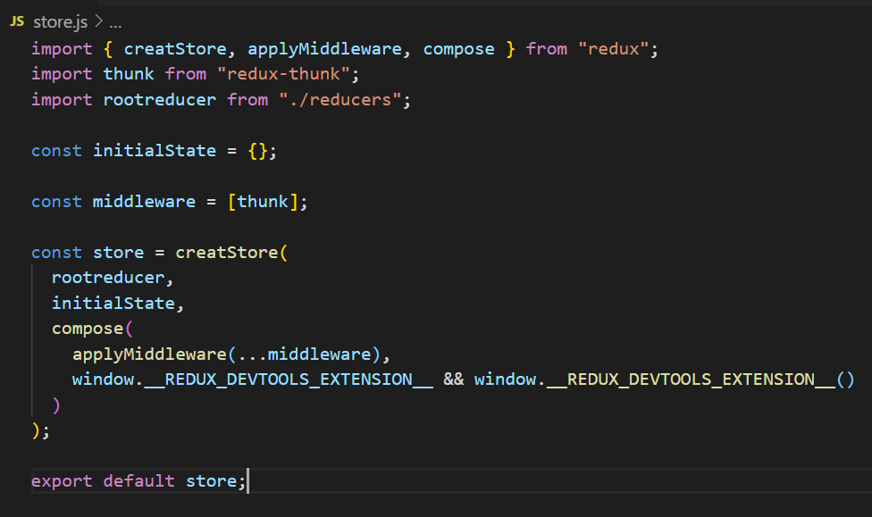

## Step 3: [Import Provider (from ‘react-redux’) and Store in App.js]

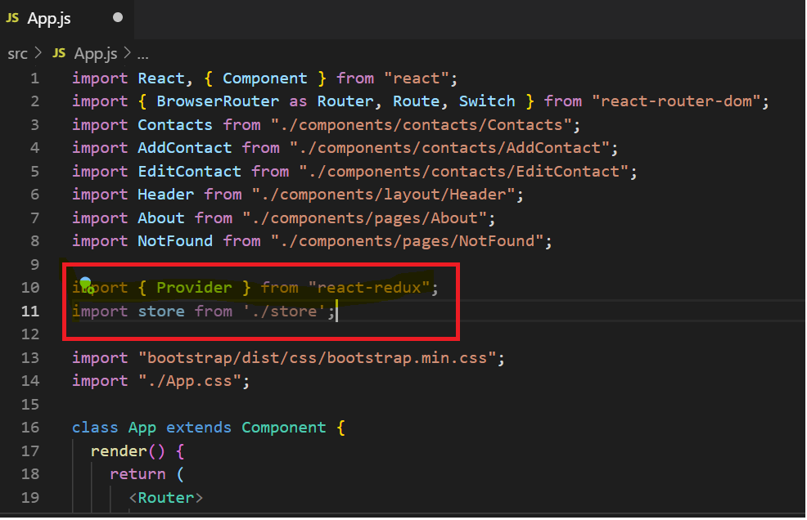

## Step 4: [Wrap Everything in App.js in Provider and Pass Store [<Provider store={store}>]]

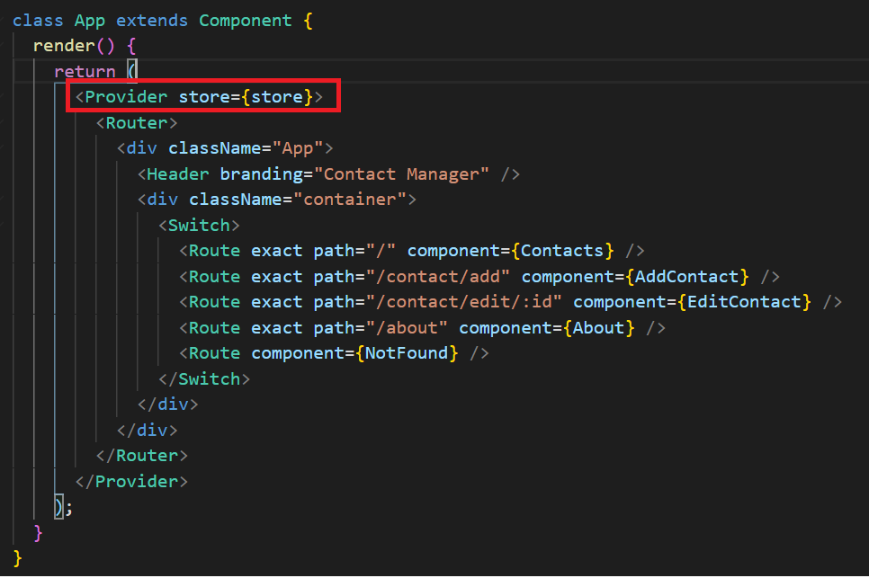

## Step 5: [Create Reducers Folder and the Corresponding index.js file for ‘combineReducers’ (from redux)and add user Defined Reducer as well {contactReducer}]

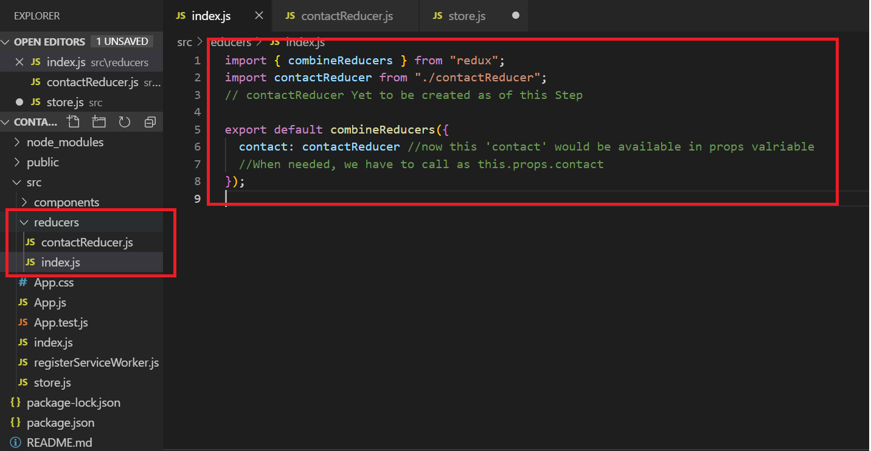

## Step 6: [Create contactReducer (Custom Reducer)]

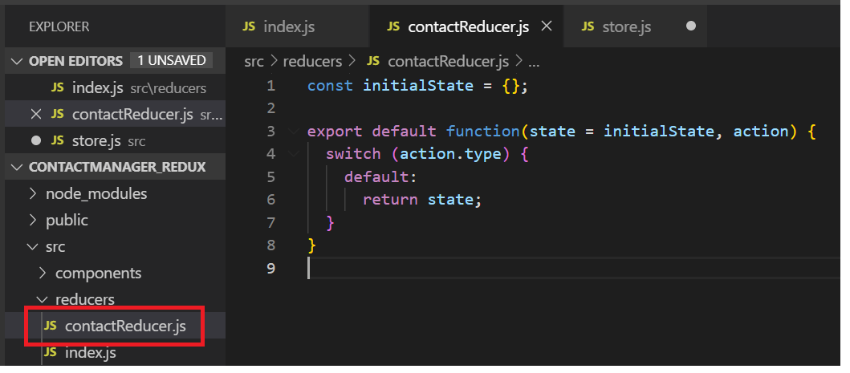

# Connecting Data to Components and Dispatching Actions:

## Step 1: [Define Types in Action Folder]

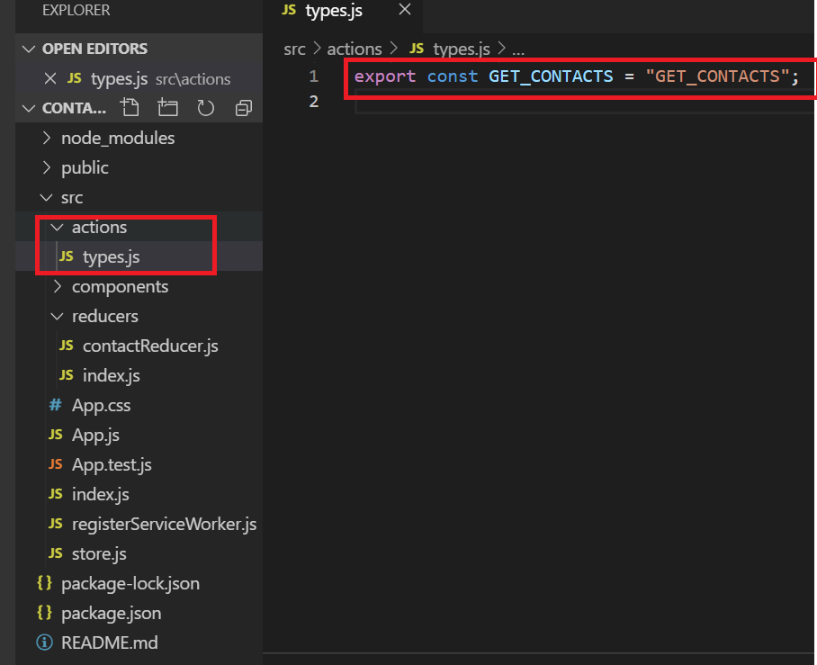

## Step 2: [Copy State in contactReducer, import action from Types.js and use it]

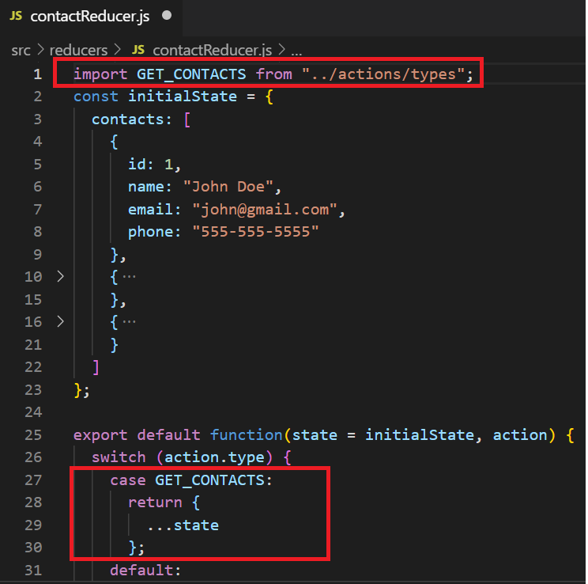

## Step 3: [Calling the GET_CONTACTS action from Contacts.js Component] [This is the Component that is supposed to display ‘Contacts’]

### Sub step 1 [Import {Connect} from ‘react-redux’]

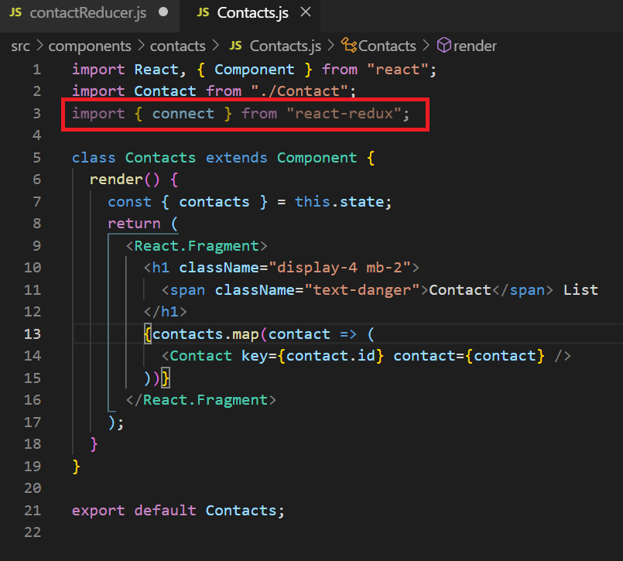

### Sub Step 2: [Import GET_CONTACTS (Action Type) from types]

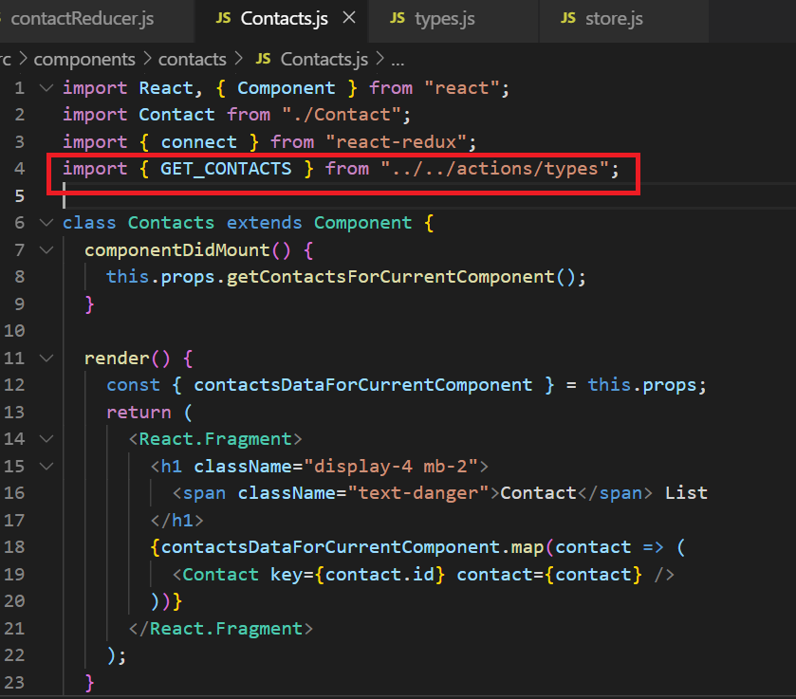

### Sub Step 3: [Create mapStateToProps function, This will Get State from contactReducer (Appropriate Reducer) to the Component]

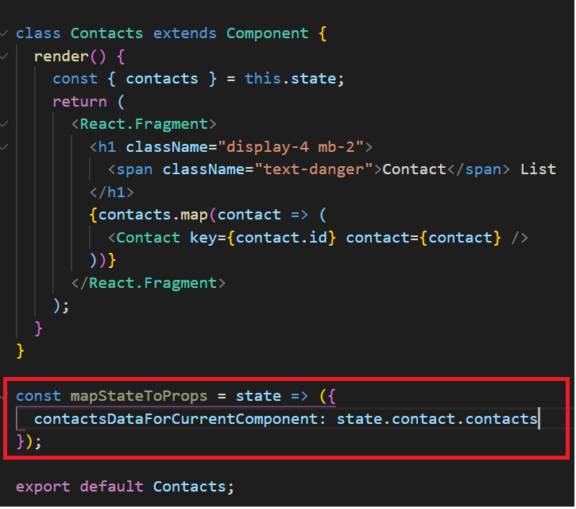

### Sub Step 4: [Create mapDispatchToProps function, This will be calling the appropriate action type {GET_CONTACTS}, this action type, will return updated contents of state related to appropriate reducer { contactReducer}, this update state, will be equivalent to “state”, which we have parameterized to “mapStateToProps” function ]

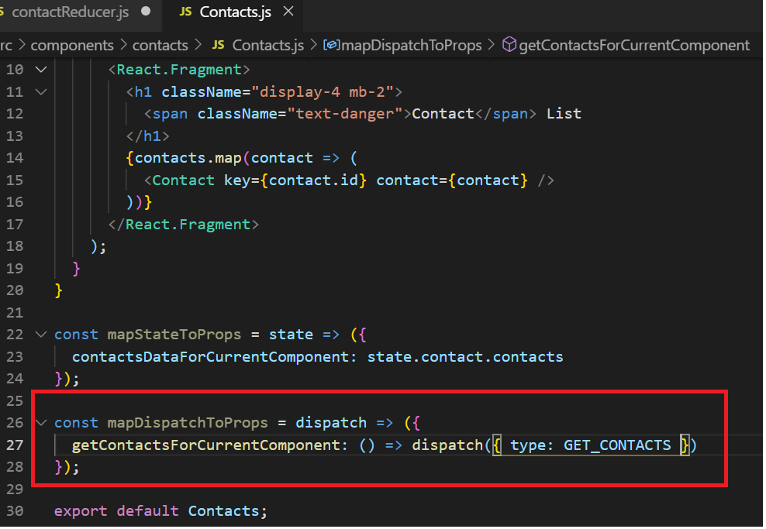

### Sub Step 5 : [Export “mapStateToProps” & “mapDispatchToProps” using Connect in the following format]

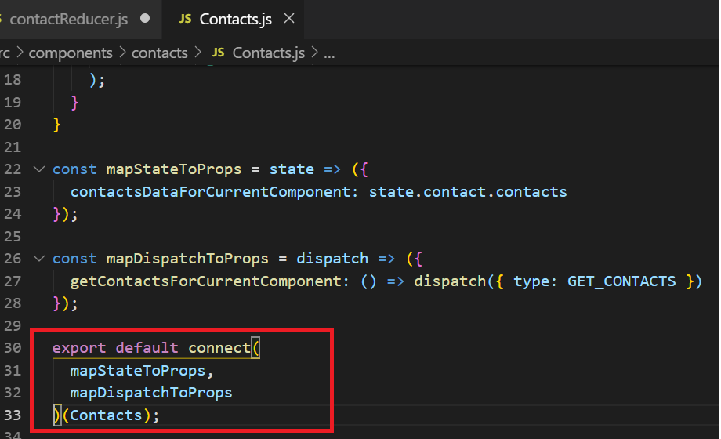

### Sub Step 6: [Finally, we have to call getContactsForCurrentComponent in the “componentDidMount” to ensure for data to be available as the component loads]

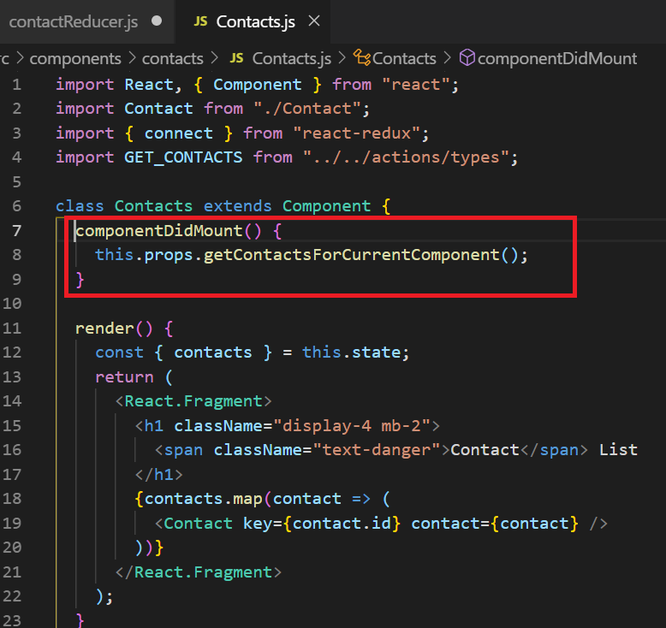

### Sub Step 7: Finally the data would be available in **variable** highlighted below, data will be available only after calling “getContactsForCurrentComponent()” function in “ComponentDidMount()”

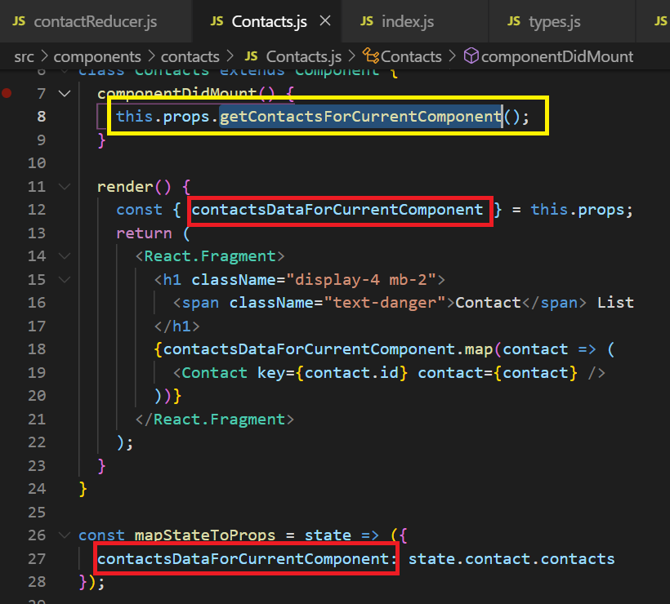

### Sub Step 8: Moving the Function which calls the Actions to a Separate File

#### Super sub step1

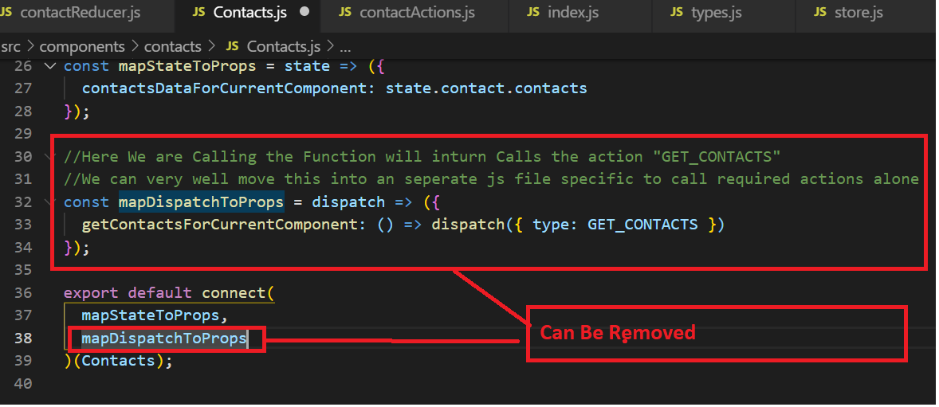

#### Super sub Step 2

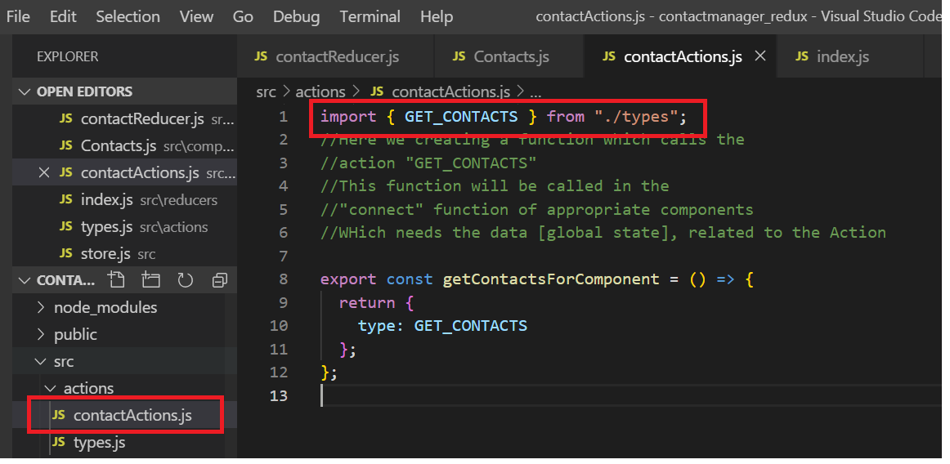

#### Super Sub Step 3:

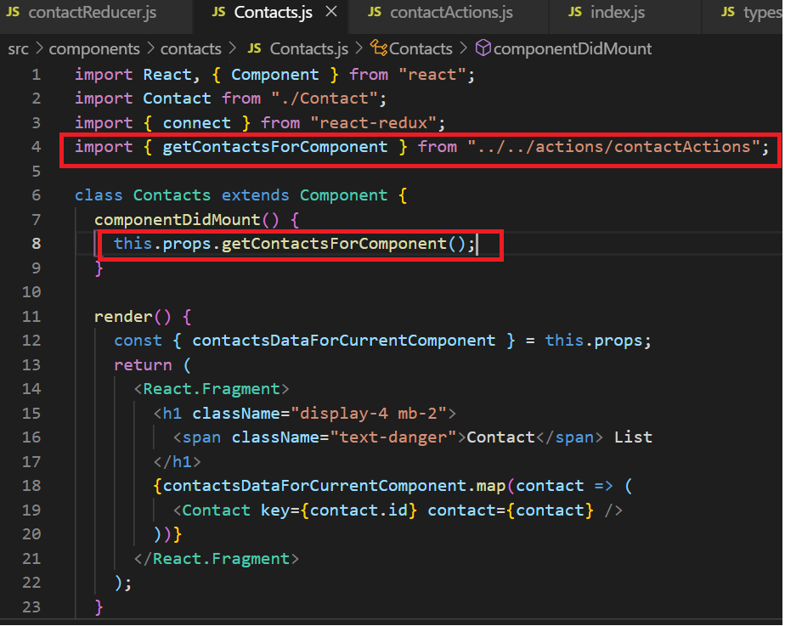

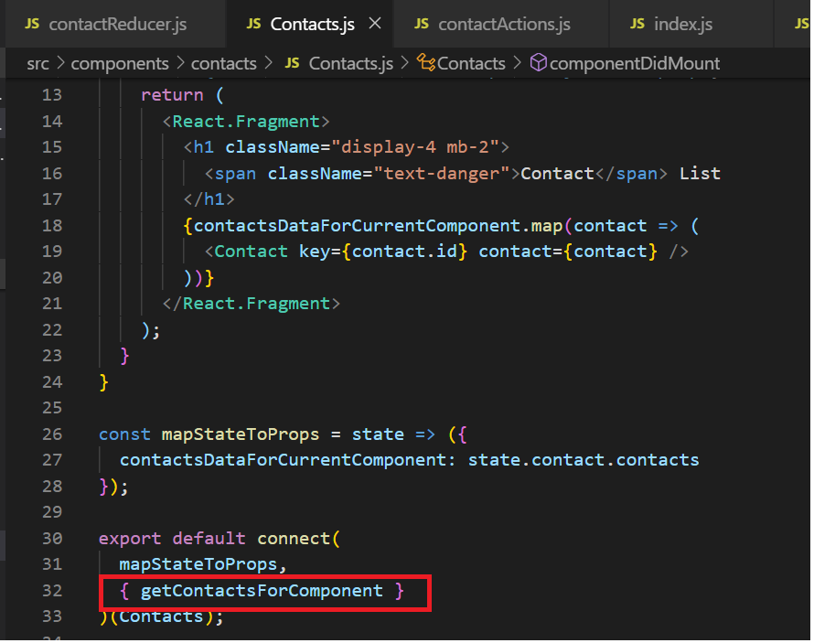

# Express Way for Learning of Actions:

## Step 1: [Add Required Action Labels to types.js]

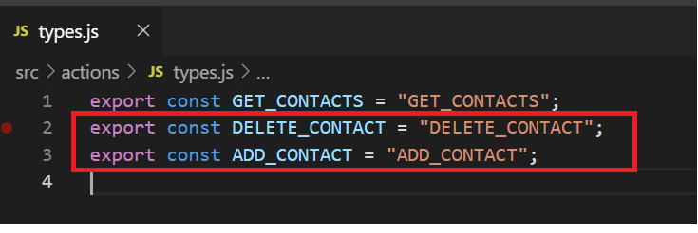

## Step 2: [Create Functions in the required “<contact>Actions” file which manipulates Global State [Data]]

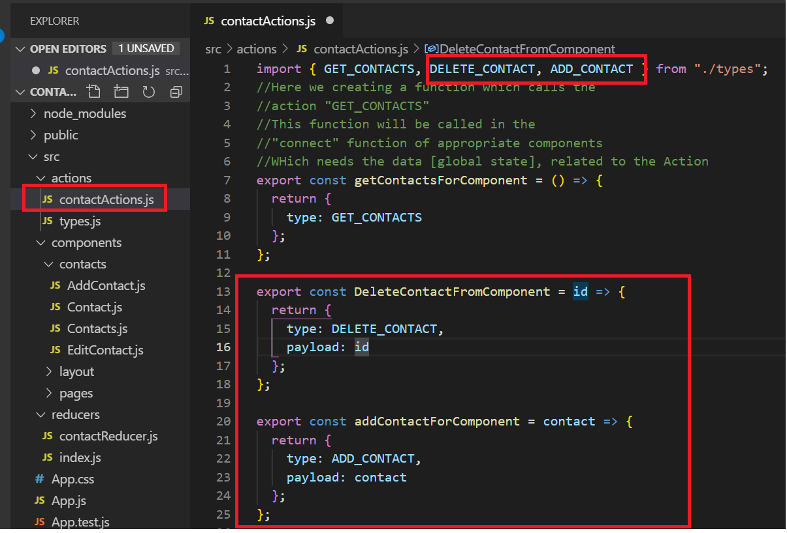

## Step 3: [Call these Functions in the which calls Actions ]

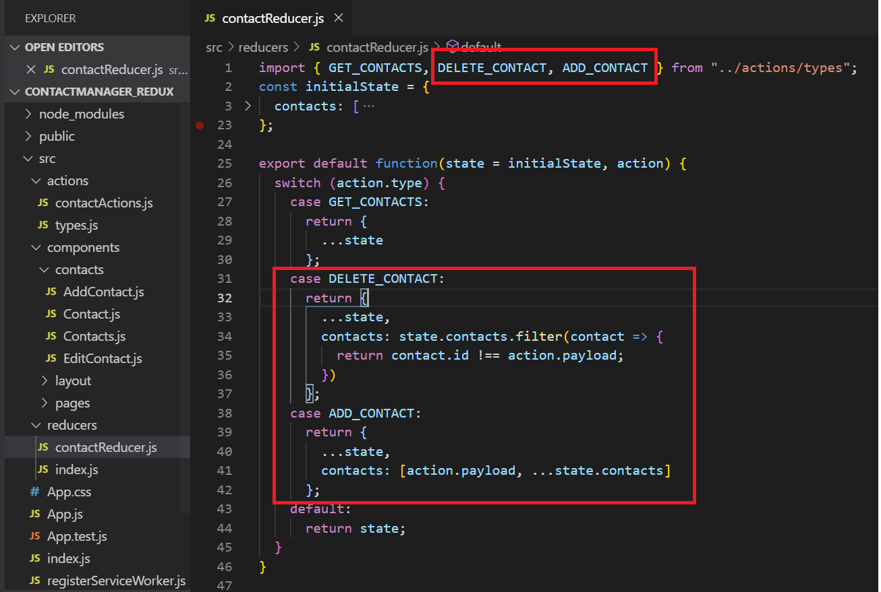

## Step 4: [From Here As usual, Import Connect and Call the Functions which inturn call the actions] [DELETE CONTACT]

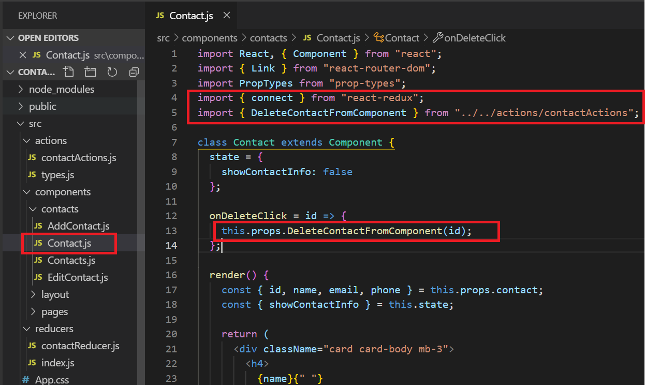

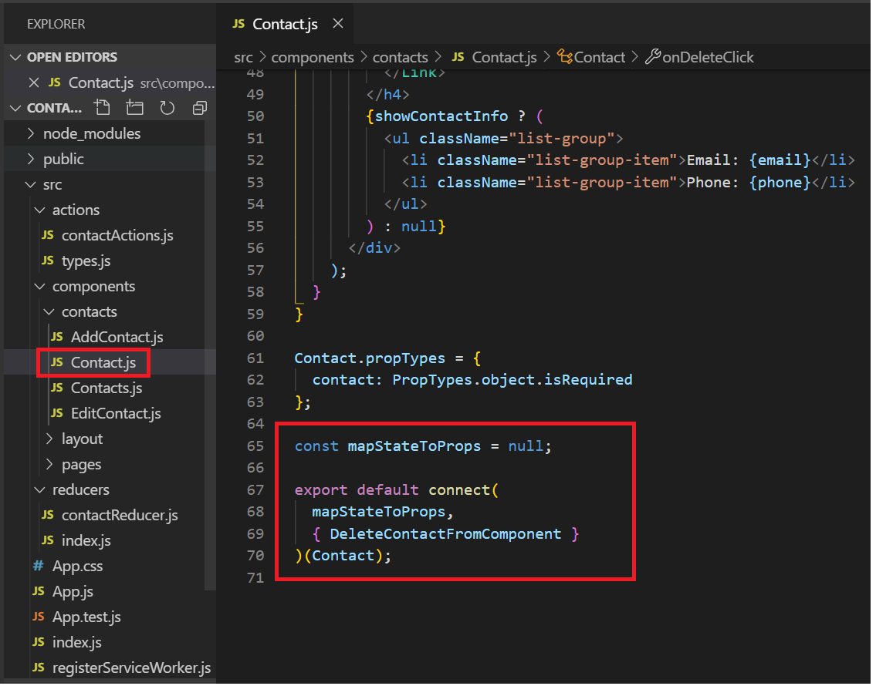

## Step 5: [From Here As usual, Import Connect and Call the Functions which inturn call the actions] [ADD CONTACT]

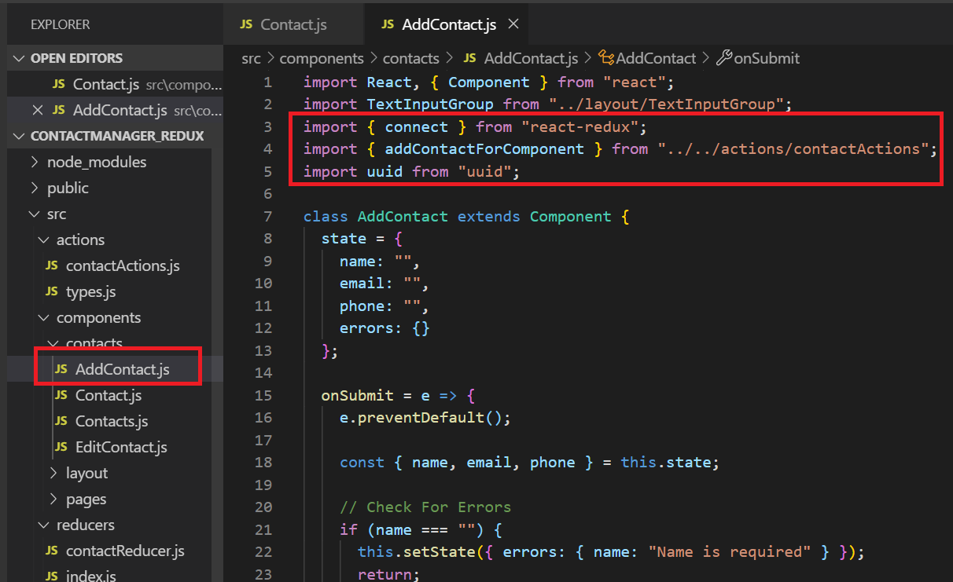

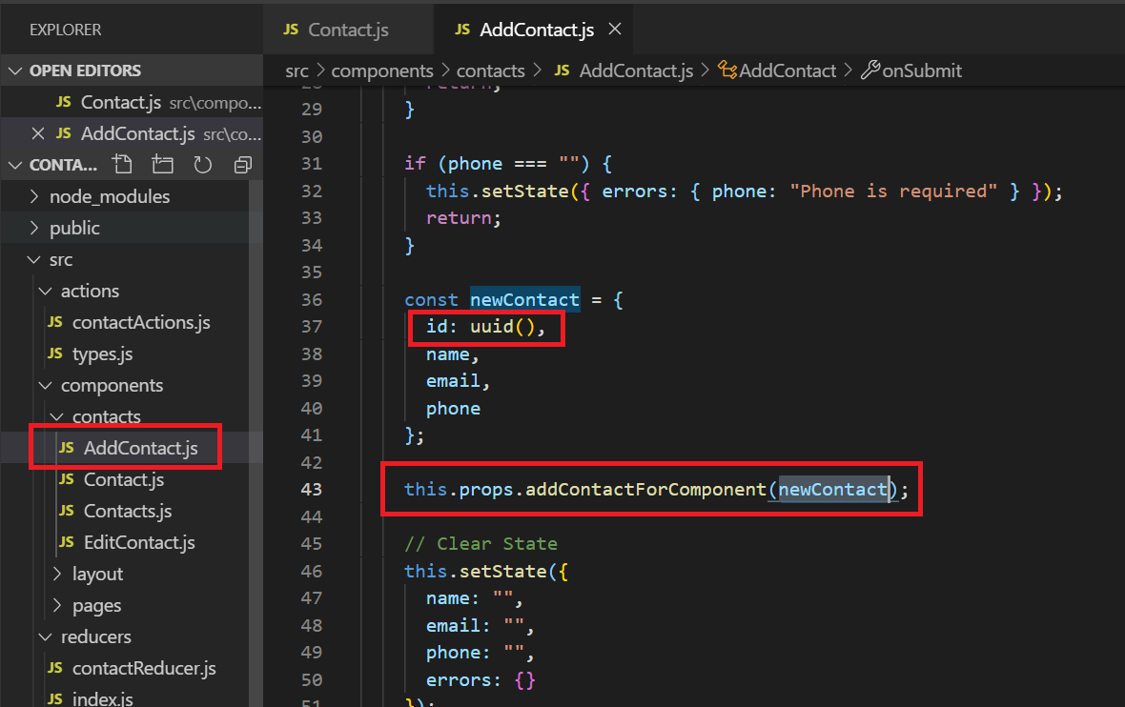

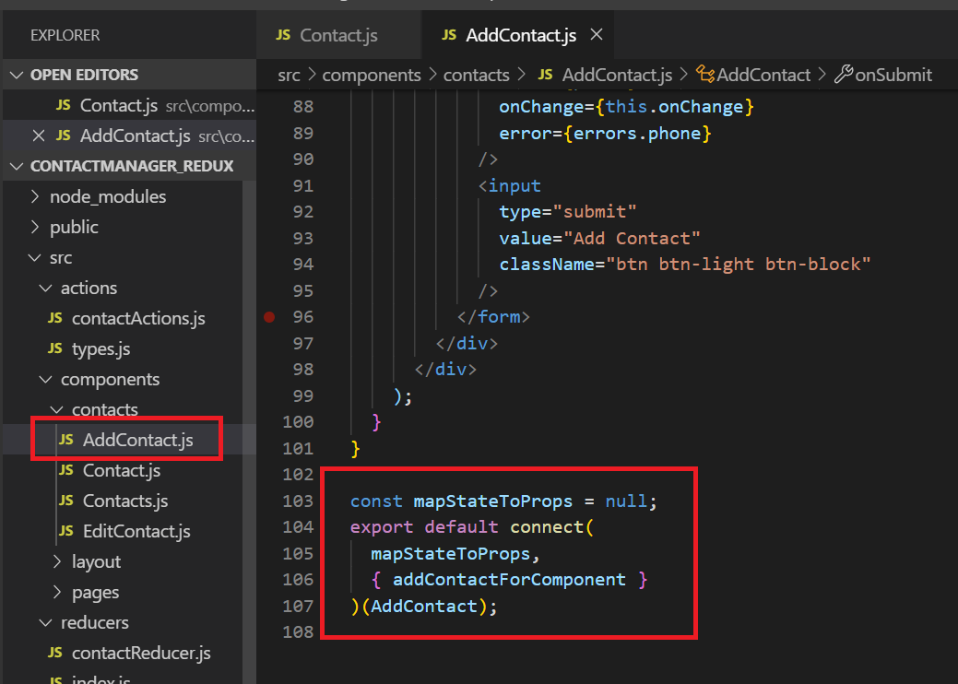

# Calling APIS

## Get API [All the API needs to be called in customAction.js file {contactActions.js}]

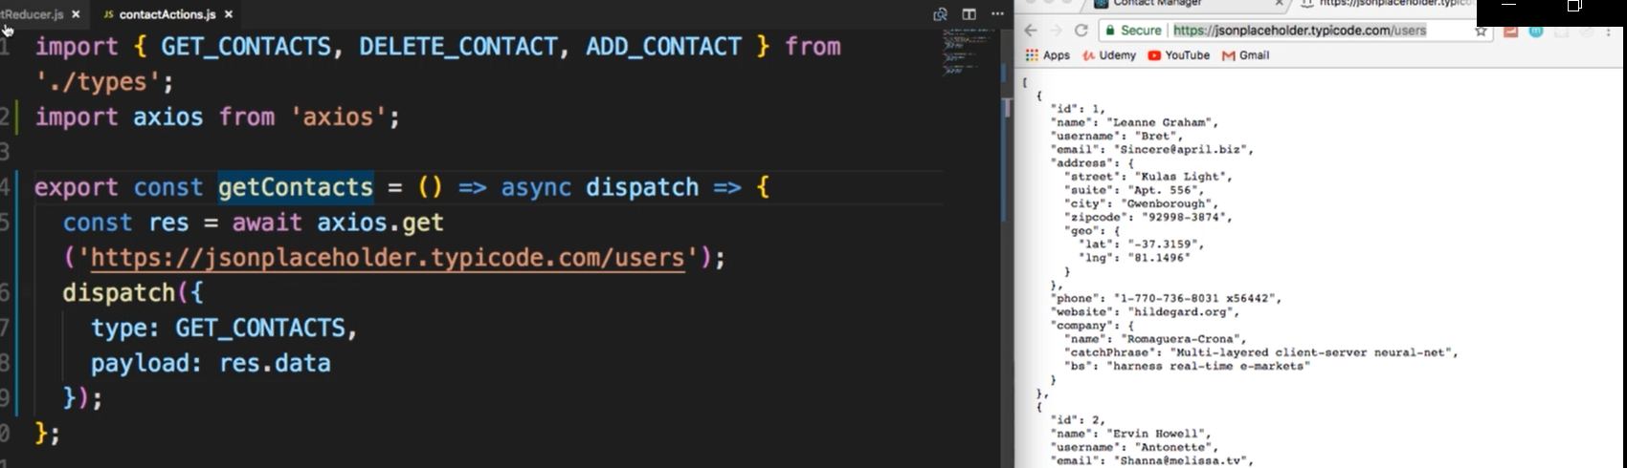

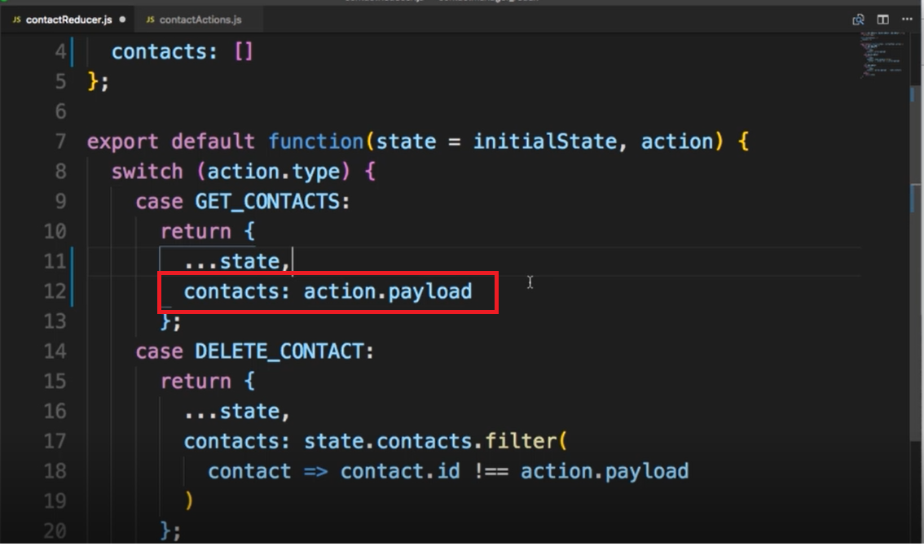

## Post:

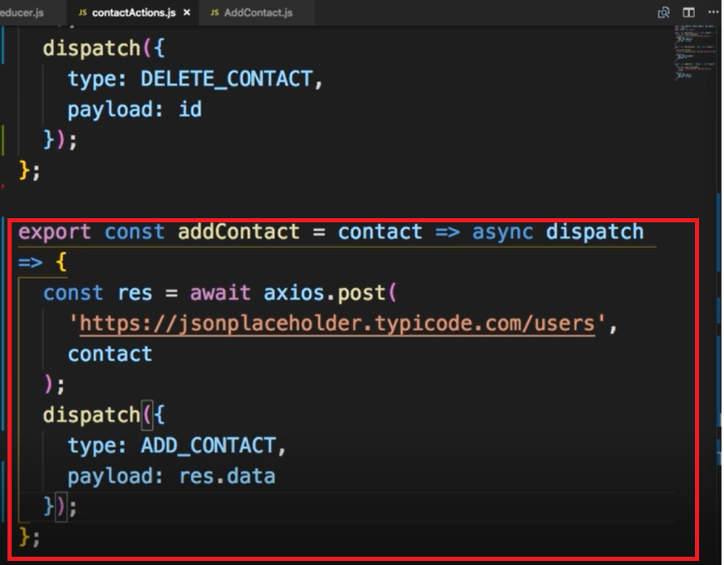

# The Sequence:

## One

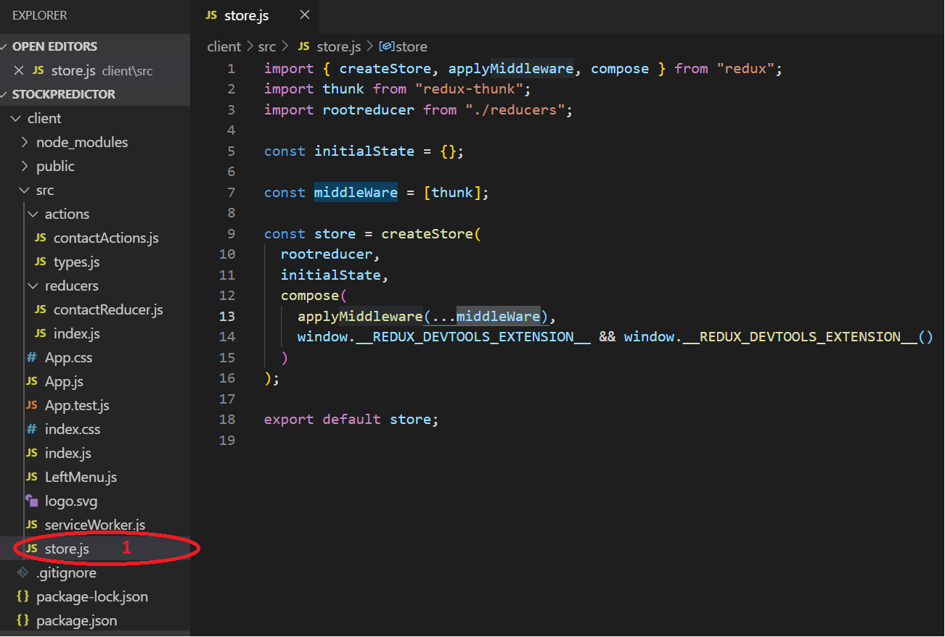

## Two:

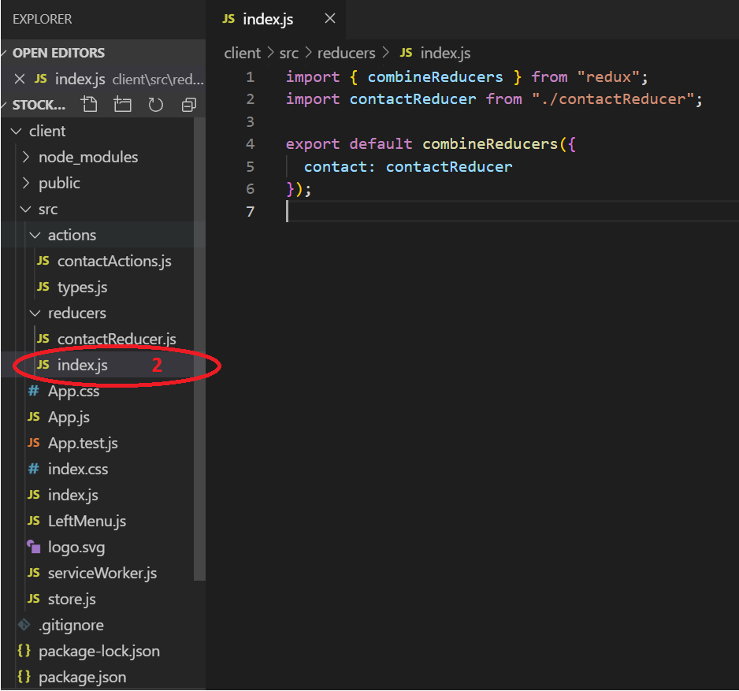

## Three:

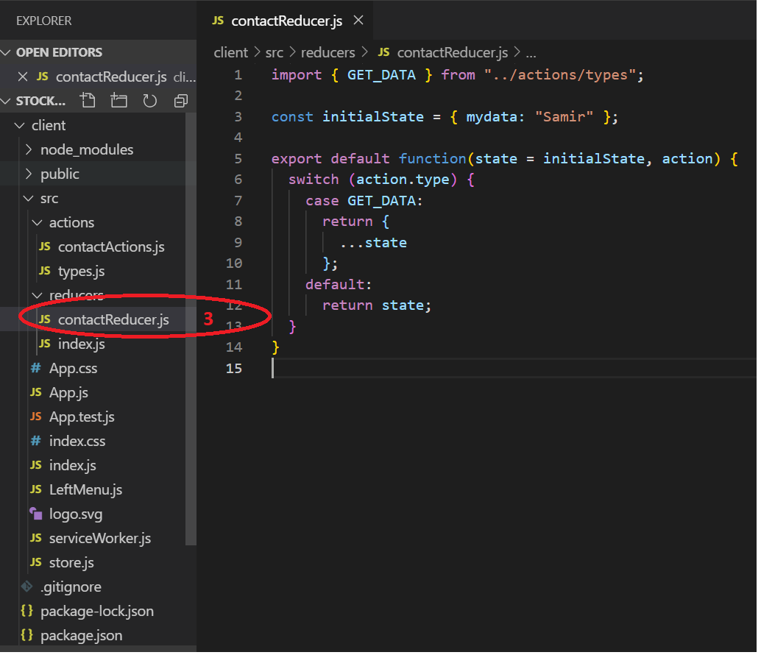

## Four:

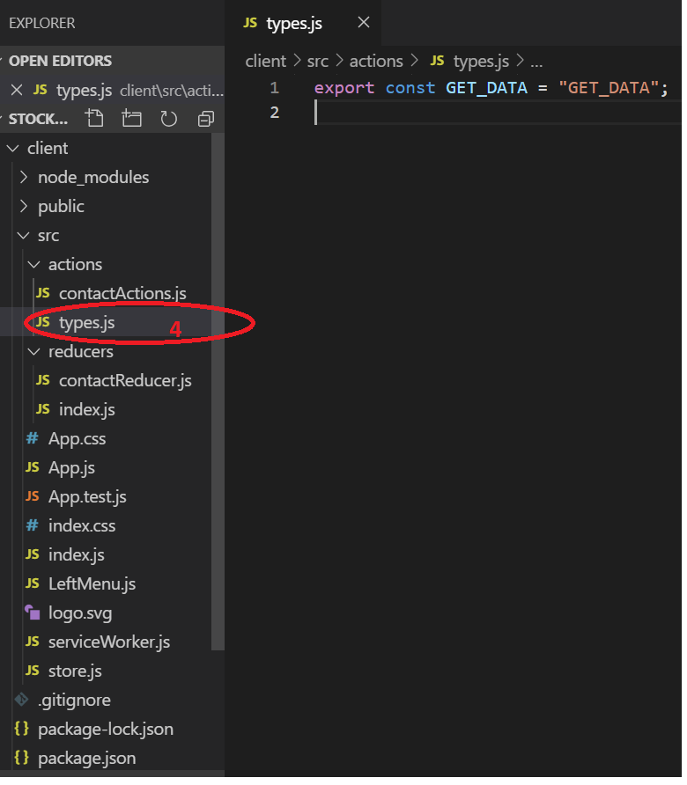

## Five

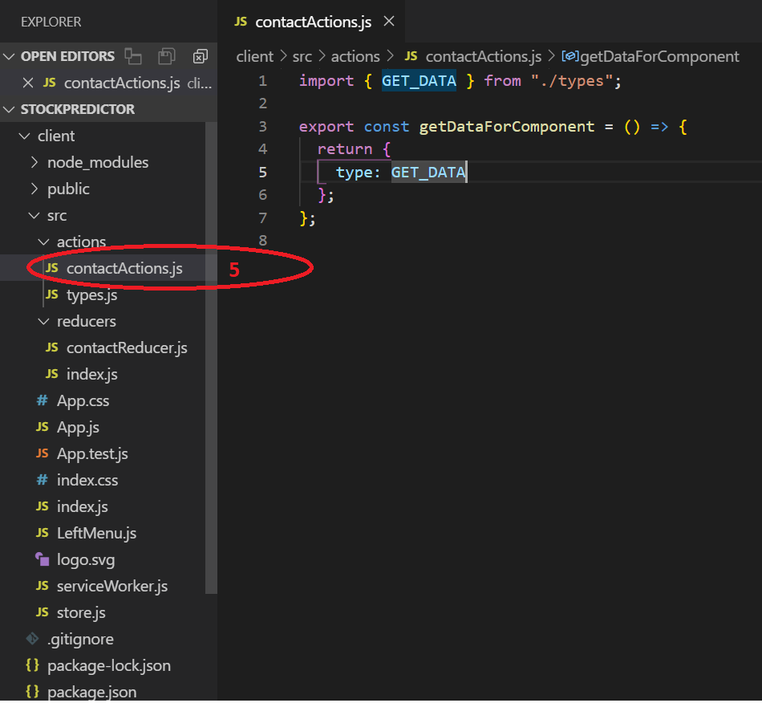

## Final

